

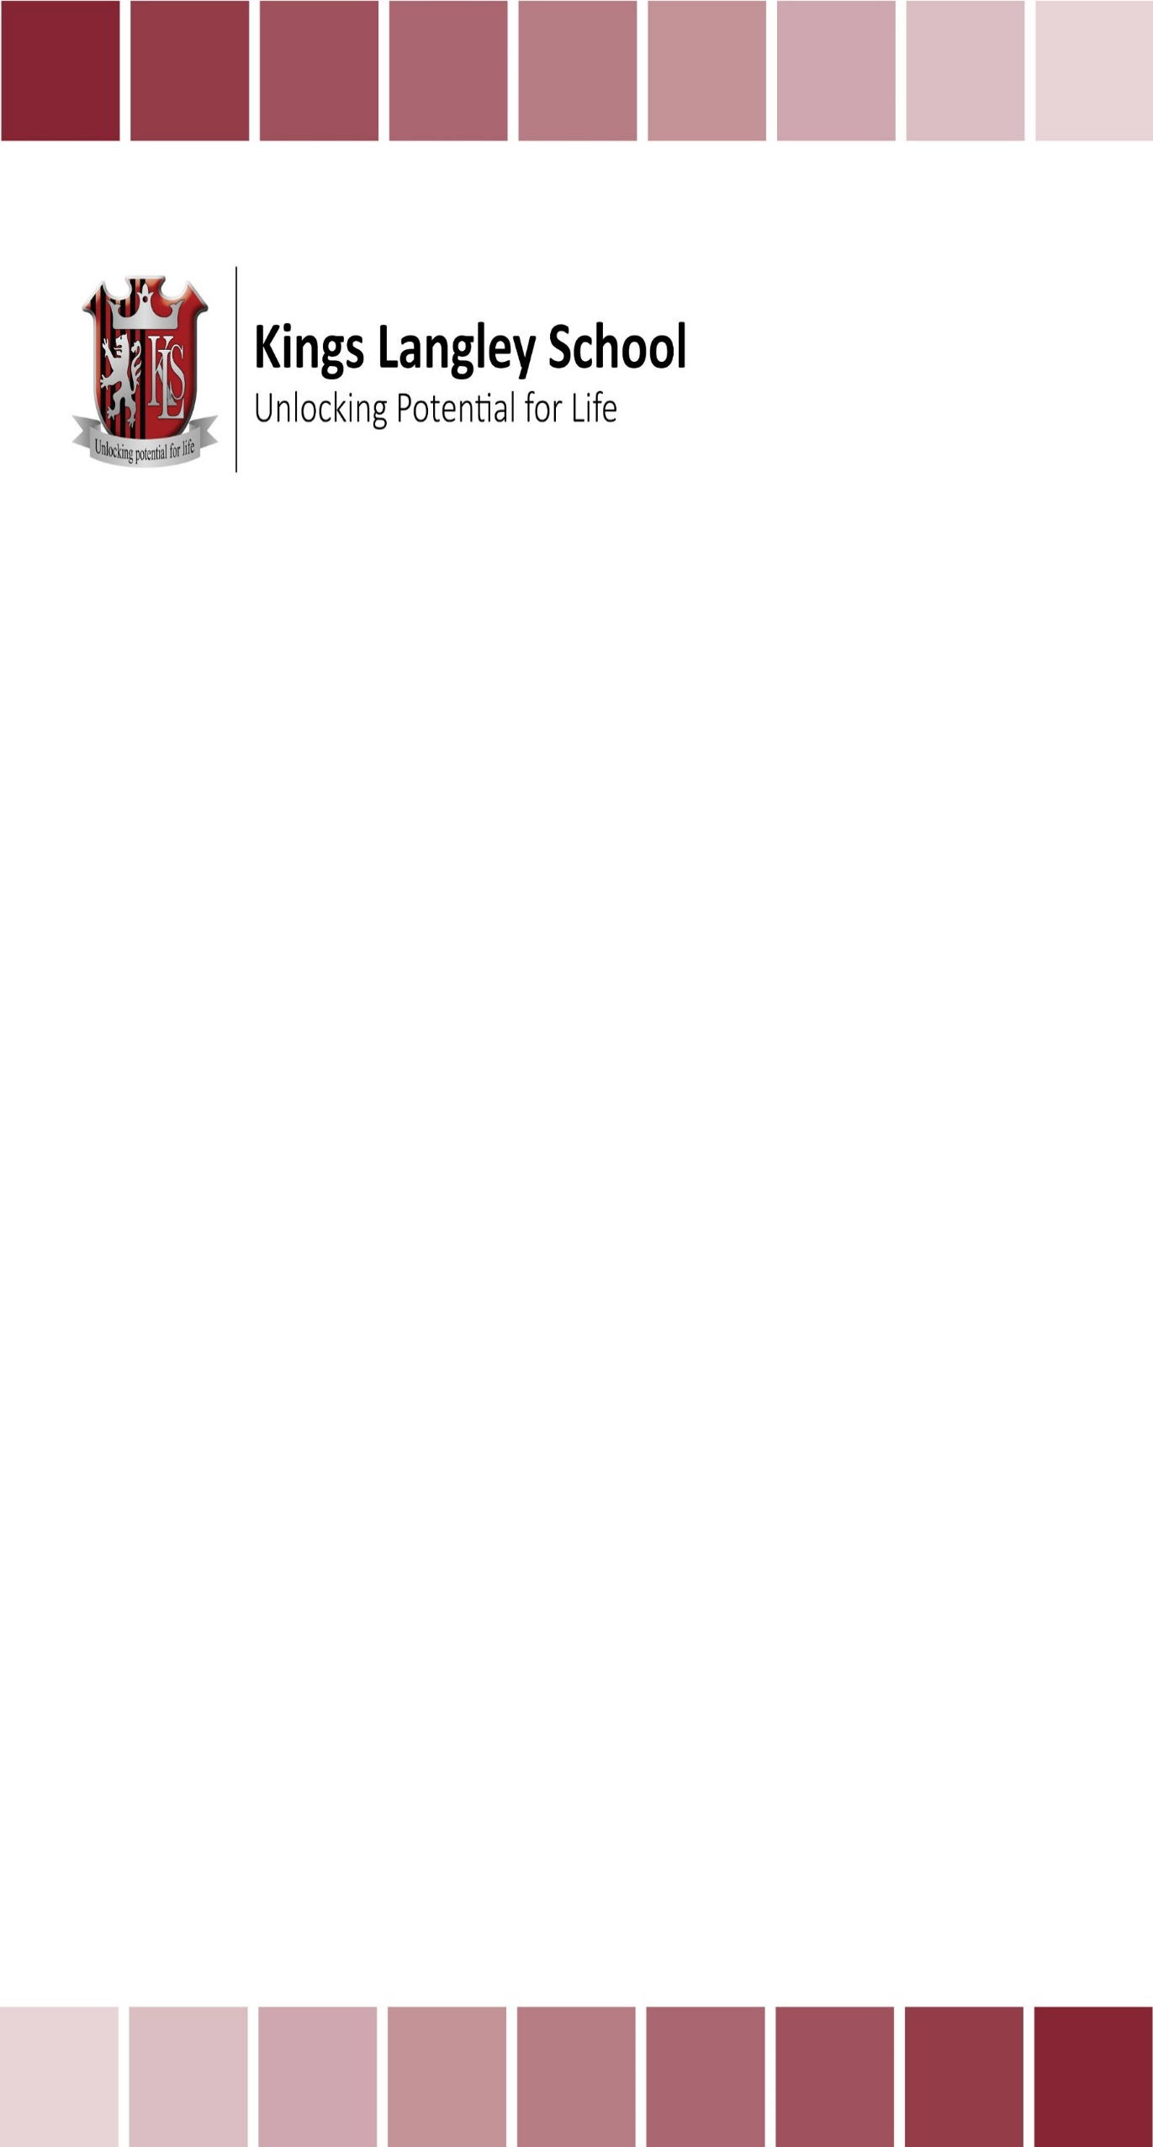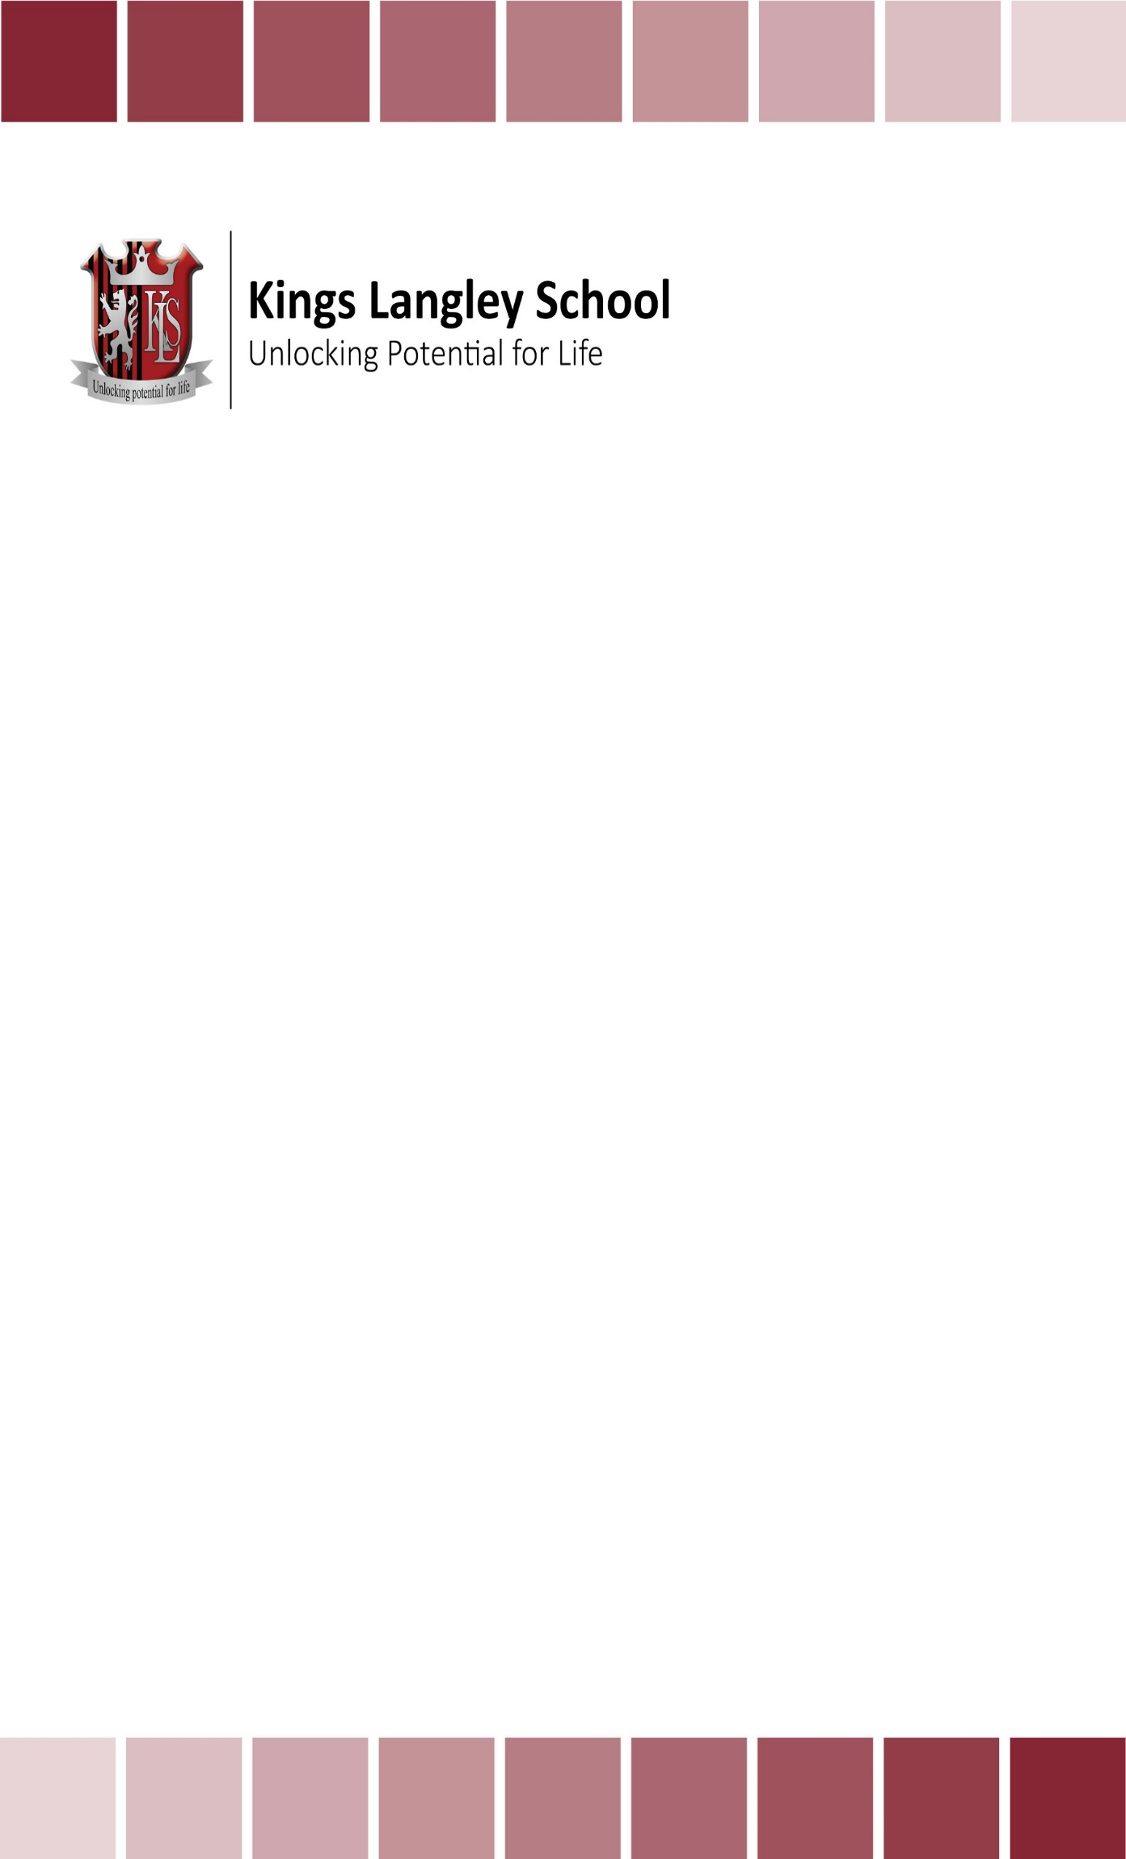

**Duke of Edinburgh Time Scale**

|  |  |  |  |
| --- | --- | --- | --- |
|  | **Autumn Term** | **Spring Term** | **Summer Term** |
| **Year 9** |  | * **Launch of Bronze DoE** | * Start two Bronze sections from volunteering; physical; or skills (3 months) * Training day in activities week |
| **Year 10** | * Start Bronze third section (3 months) * Sign off previous two sections * **Bronze Practise and Assessed Expeditions (3 days)** | * Signing off third section * **Launch of Silver DoE** * Start Silver first section from volunteering, physical; or skills (6 months) | * Start other Silver two sections from Volunteering; physical; or skills (3 months and 6 months) * Sign off first section * **Silver Practise Expedition (3 days)** |
| **Year 11** | * Sign off second section (3 months) | * Sign off third section (6 months) | * **Assessed Silver Expedition (3 days)** - *After examinations* |
| **Year 12** | * **Launch of Gold DoE** | * Start all Gold sections * **Gold Practise Expeditions** | * **Gold Assessed Expeditions** |
| **Year 13** | * Signing off completed sections |  | * Residential Activity - *After examinations* |